Phishing detection Websites Using SVM and light GBM
1.Project Overview
Phishing websites are illegal websites which are designed to trick users into revealing sensitive information such as Username, passwords, bank details or personal information regarding finance. This project is a machine learning based on phishing websites detection system using SVM (Support Vector Machine) and Light GBM
This system consists of the dataset contain URL using these two machine models they are trained for tracking the URL and generating whether the website is legitimate and phishing.
2. Objectives
- Detects whether the website is legitimate or phishing
- Analyses and cleans the website dataset
- Train SVM model
- Train light GBM model
- Compare model precautions using accuracy, precision, recall, F1-Score
- Provide a simple web interface using python and Flask
- Preprocessing the data and training the model
3. Technology Used
- Python
- Matplotlib
- Pandas & NumPy
- Light
- SVM
- Flask
- Sklearn
- VS code
4. Dataset
This project uses UCI Phishing dataset. It contains multiple features which describes about the URL. The dataset consists of columns in binary format with implementation result.
- Original targeted value 1=Phishing
- Original target value 1=legitimate
- For the model output result 1=phishing and 0=Legitimate
5. Model structure
Taking the dataset for website

Predict the website
Evaluate model
Light GBM model
SVM model
Processing the data

6. Detailed Structure
Remove Duplicate
Load CSV
Taking the dataset into external fine
Dataset -------CSV

X Data
Soring the values and f
Result

Y label
Evaluation
Model
Testing
Training
Split 80/20

7. Installations and requirements
Install Python, open VS code and run these libraries:
pandas
NumPy
scikit-learn
light
matplotlib
seaborn
joblib
stream lit

8. Data processing
The preprocessing stage which loads the dataset, removes the duplicate rows, separates the target column, converts the feature values to numeric form, missing values divides the data into training and testing using an 80:20 stratified split.
SVM is sensitive scale so the scale fitter used to train the data and used to transform the training the features. The scaler is saved for future SVM predications.

9.Model Training
Training the model with machine learning algorithm finding the accuracy, precision, F1-score and recall score. Generating the SVM model by predicting the value. Finds the boundary between classes.
10.Prediction workflow
10.1 Converting the dataset
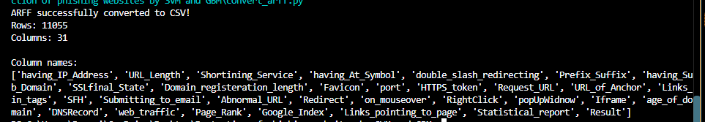
Now we can view the number of rows the dataset has in it and changed them in CSV model.
10.2 Training the model
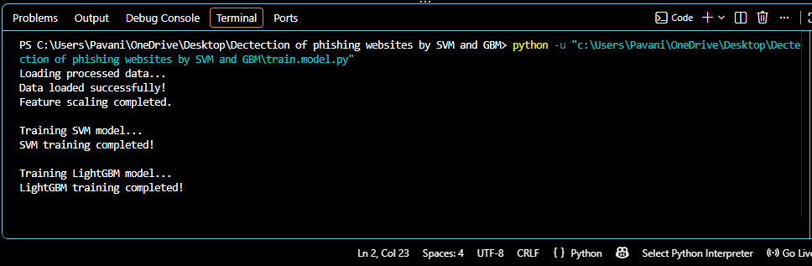
10.3 Calculating the values and results
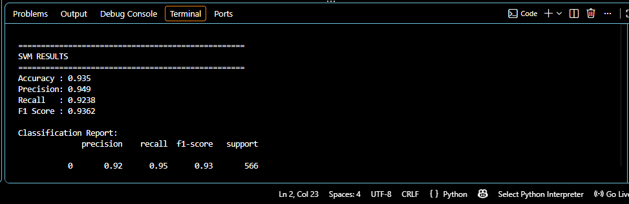
10.4 Finally predicting whether the website is true or not
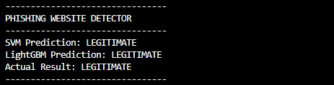
11. Future enhancement
- Add a modern web interface
- Add light GBM feature visualizations
- Use a larger and more phishing dataset
- Add automated model retaining
- Deploy the application with cloud platform
12.conclusion
This project demonstrates how machine learning can be applied to identify whether a website is phishing or not. SVM provides a kernel-based application whereas the light GBM provides a tree-based boosting approach. This project also shows us the preprocessing, evaluating model, web app integration. the project could be extended with real-time URL feature extraction , explainability tools like SHAP to justify individual predictions, and a live backend serving the actual trained stacking model instead of a heuristic demo turning this from a proof of concept into a deployable browser or email-client plugin.

